
ОБЩЕСТВО С ОГРАНИЧЕННОЙ ОТВЕТСТВЕННОСТЬЮ
«ЛАЗЕРТАГ»

ПАСПОРТ

Смоленск
LIMITED LIABILITY COMPANY
LASERWAR

Smart Control Point
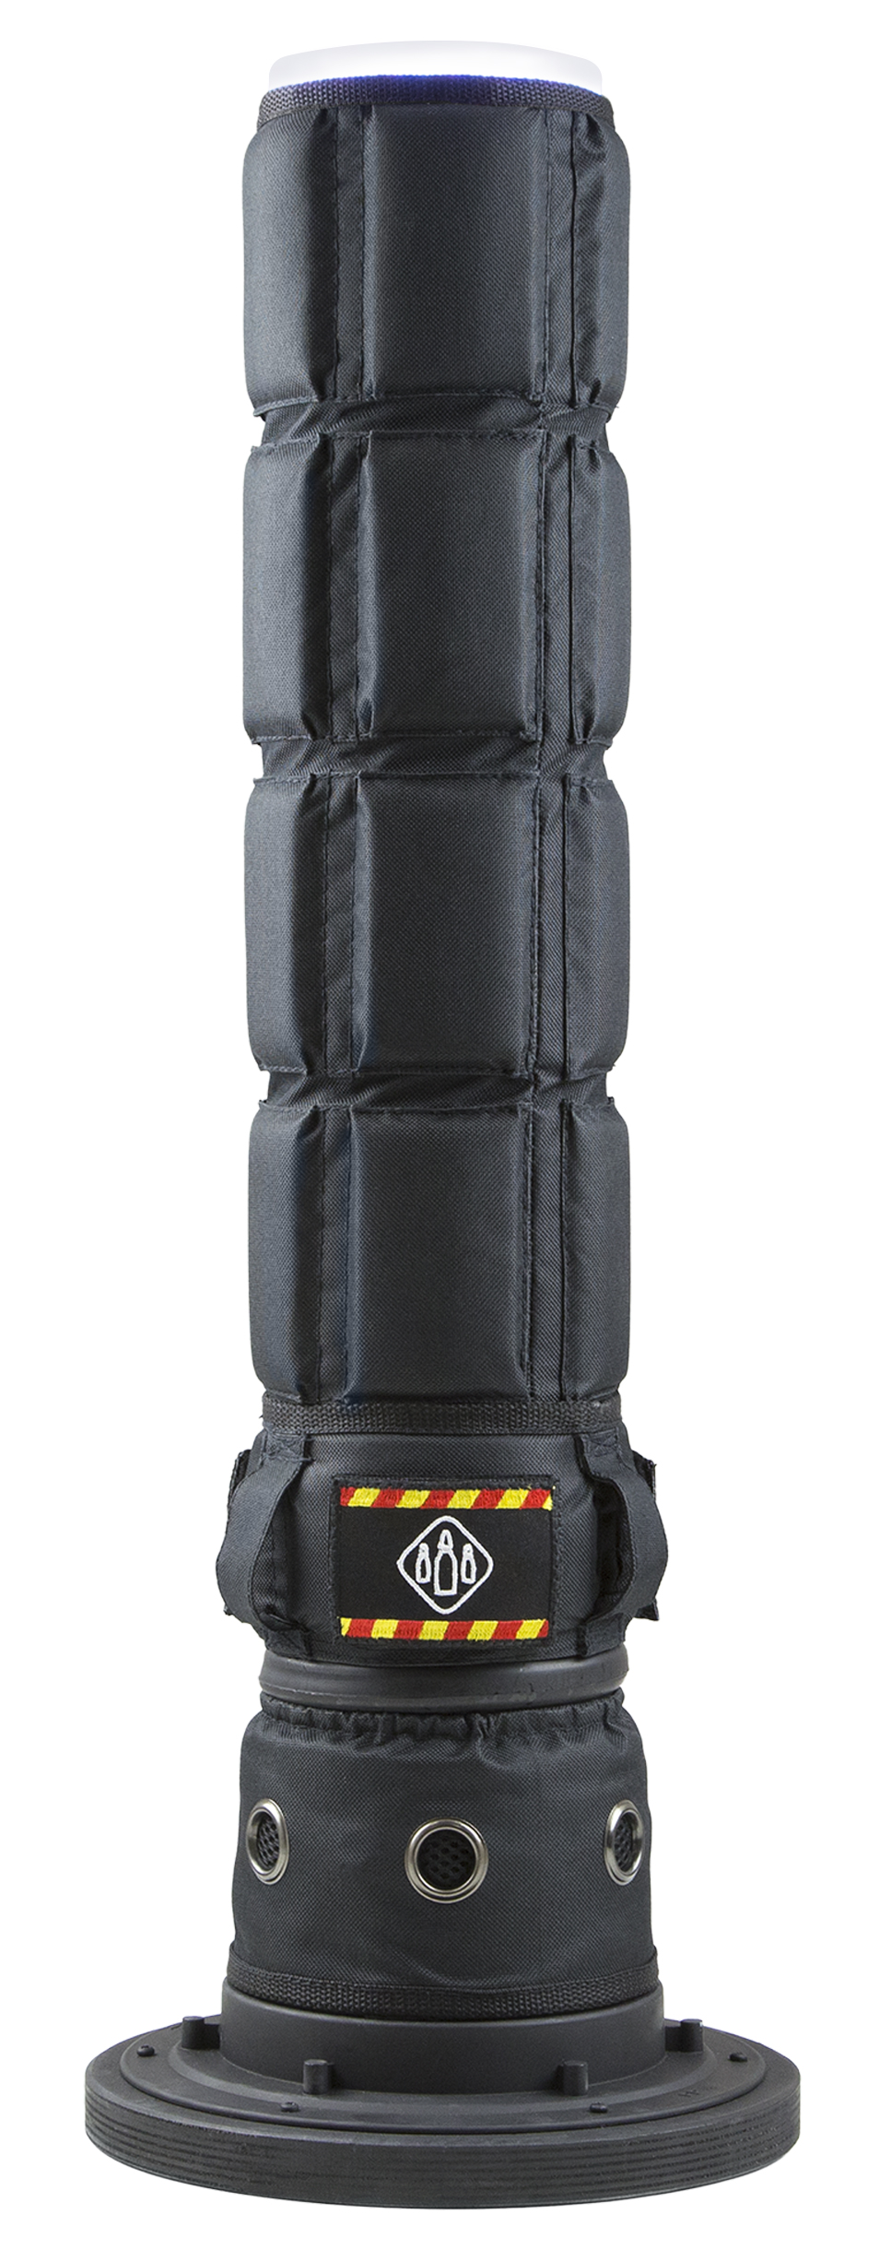
SPECIFICATION
8. Contact details

Official website:
www.laserwar.com

E-mail: Purchase date: _________________________
info@laserwar.com
help@laserwar.com

Skype:
info@laserwar.com
help@laserwar.com

______________________________________
signature

Dear Customer!
Thank you for choosing our products! LLC LASERWAR would like to assure you that you will enjoy the purchased device and it will serve you long. This slip sets out the terms of the warrantee as defined by the law of the Russian Federation “About consumers’ rights protection”.
This warrantee slip is valid for a period of 6 months from the purchase date provided that the terms and conditions set out in this warrantee are complied with.
Warrantee terms and conditions:
1. The warrantee comes into force upon presenting of this slip, with a confirmed by a repair centre date of purchase displayed on it.
2. This warrantee only covers the devices purchased from an official representative of LLC LASERWAR, or its official dealer.
3. This warrantee does not cover product defects that resulted from:
- the customer not complying with the directions outlined in the User’s manual;
- physical damage;
- any objects or liquids getting inside the device;
- damage by animals;
- unauthorized access to the units and details of the device;
- abuse or misuse, including failure to use this product for its normal purposes;
- any cause beyond the control of the company, Force Majeure (natural catastrophes, fire, accidents, etc.);
- device failure due to being incorrectly connected, voltage fluctuations, and/or improper care.
4. Should it happen that you lose your warrantee slip, you will not be issued a copy.

2
7
1. Descripton
The Smart control point is an additional play device that can be used for various game scenarios.

2. Application area
The device can be used during laser tag events, tactical trainings, corporate and entertainment events.

3. Delivery set
- Smart control point - 1 pc.
- Item specification - 1 pc.

4. Technical specifications
Height, mm | 680
Base diameter, mm | 240
Accumulator type | Lithium-ion
Accumulator capacity | 3000 mAh
Charger type | Li+
Weight, kg | 2,1

5. Construction
The Smart control point consists of a black plastic tube covered with camouflage fabric, a base at the bottom of the construction,

Information about maintenance works during the warrantee period (filled out by a repair centre):

Date:__________________  Maintenance carried out: _____________________________________________________________________  Repair centre stamp | Date:__________________  Maintenance carried out: _____________________________________________________________________  Repair centre stamp
Date:__________________  Maintenance carried out: _____________________________________________________________________  Repair centre stamp | Date:__________________  Maintenance carried out: _____________________________________________________________________  Repair centre stamp
Date:__________________  Maintenance carried out: _____________________________________________________________________  Repair centre stamp | Date:__________________  Maintenance carried out: _____________________________________________________________________  Repair centre stamp

3
6
an on/off switch inlet and an admin button.
The accumulator, control units, modules mounts, a protective glass as well as a sound element have been integrated into the main construction of the device.
6. Using the device
After activation the device will enter work mode.
Current scenario number will be displayed on the indicator. Time to scenario start will be displayed on the circular scale and on the indicator. You can switch between scenarios by pushing the button. When ‘New Game’ command is sent through the infrared channel, the current game will be interrupted and new countdown will start. On sending ‘Game Start’ command the current scenario will be immediately launched or restarted.
7. Changing technical and tactical characteristics
To enter admin mode, turn on the device making sure that you holding the button at the same time. After entering admin mode, you can change scenario settings either by means of the infrared base or on the device itself. On changing the parameter, the category that is being changed will flash. To edit a preceding category, push and hold the button for more than 3 seconds. To exit the parameter editing mode, go to a preceding category and push and hold the button for more than 3 seconds.
Using your device
1. Weather conditions. During the process of production the equipment performance is tested at various weather conditions. In spite of this, we strongly recommend that you do not use the equipment in rainy weather and at a temperature below -20°С.
What must you be aware of when using the play sets in poor weather conditions?
More than anything else, avoid humidity getting inside the device. Should this happen – stop using the device and let it dry at room temperature for at least 2 hours.

2. The accumulator. Lithium-ion accumulators with a capacity of 3 Ah are used in the ‘Digital RGB Checkpoint’ play set.
You must use a Li+ charger to charge the accumulators.

The equipment must be stored in a well ventilated room at a temperature of +18°С to +30°С and air humidity 45% to 65%.
The accumulators, speakers and infrared modules are supplied with a 14 DAYS WARRANTY.

ATTENTION! If the battery is used incorrectly (wrong battery charger is used to charge the equipment), the accumulators will no longer be covered by the warrantee!

4
5

